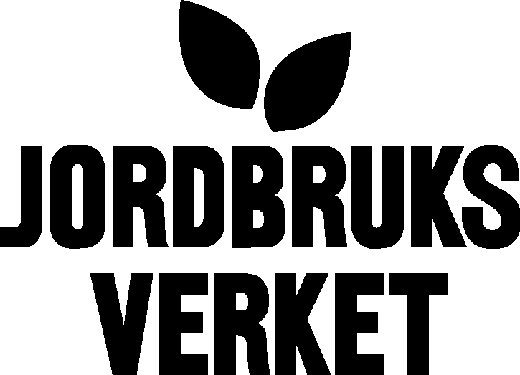  Swedish Board of Agriculture |  | 27-05-2004
Division of strategic issues
E-mail: eva-marie.stalhammar@sjv.se

Annual report 2003/2004 on activities of AnGR in Sweden

Accomplished tasks

Inventory of the semen bank
Semen collecting from our endangered local breeds has been on going since 1993 under the regime of Swedish Board of Agriculture. Today the semen bank comprises of totally 53 858 doses of bull semen, 1226 doses of ram semen and 1 490 doses of buck semen. Thanks to the breeding organisations and other’s often idealistic work in this field, we’ve been able to build up a gene bank with frozen semen from several endangered species.
The Board is responsible for the financing. Annually about 10 bulls are collected and 2000 –3000 semen doses are processed. One third of the doses are sold to farmers with endangered breeds. In June 2003 the gene bank of bull semen comprised 53 852 doses from 172 bulls of principally six different breeds Fjällras, Fjällnära, Väne, Bohuskulla, Ringamåla och Rödkulla.

No. of semen doses per breed in the gene bank
Breed | No of bulls | No of doses
Fjällras | 88 | 28 715
Fjällnära | 9 | 2 064
Rödkulla | 30 | 7 222
Väne | 18 | 6 290
Ringamåla | 8 | 2 005
Bohuskulla | 2 | 437
Telemark | 7 | 3 247
Fjordfe | 7 | 2 205
Vestlandsfe | 2 | 1 191
Döle | 1 | 476
Total | 172 | 53 852

The semen collecting from endangered sheep and goats started in 1998. There are 1226 doses of 20 rams from four sheep breeds and a total of 1490 doses from 15 bucks. There is no sale of semen from rams or bucks.

In year 2003 1.6 milj SEK were distributed to the associations working with endangered breeds to increase farmer’s education/competence within the environmental and rural developement programme. About 4 million SEK were distributed in 2002 as an environmental aid to farmers involved in the preserving work of endangered breeds in accordance with the EU legislation (445/2000/EG). The number of breeds and animals were in year 2002 and 2003 respectively.

Endangered farm animal breeds total number and number of animals, for which the farmer received environmental aid ¹.
Breed | Total no of animals 2001 | Total no of animals 2002 | No of animals¹  2002 | No of animals¹  2003
Bohuskulla | 21 | 21 | 14 | 17
Fjällko | 2 630 | 2 495 | 2667 | 3299
Ringamålako | 107 | 107 | 66 | 72
Rödkulla | 760 | 1100 | 985 | 1308
Väneko | 180 | 180 | 147 | 166
Dala pälsfår | 95 | 95 | 55 | 84
Gutefår | 6 117 | 5 617 | 3302 | 3830
Roslagsfår | 425 | 425 | 191 | 317
Ryafår | 1 560 | 1 560 | 1113 | 1271
Skogsfår | 1 900 | 1 554 | 709 | 1287
Svenskt finullsfår | 2 351 | 2 900 | 1721 | 2258
Göingeget | 66 | 66 | 7 | 19
Jämtget | 106 | 106 | 34 | 46
Lantrasget | 1 339 | 2 500 | 1506 | 1367
Linderödssvin | 224 | 247 | 206 | 219
Source: Swedish Board of Agriculture and the breed associations in the register of the Nordic Genbank Farm animals see www.nordgen.org

The national programme for managing the AnGR
The proposed programme for national management of farm AnGR was delivered to the governement in June 2003. This programme is the following up of the Country Report.
The programme suggests among other things a change of the law regulating the statutes for breeding organisations to make clear the responsibilty according to the CBD which concerns every stakeholder with a response to breeding and preventing animal health care; an Advisory Committy is established for animal genetic resource issues. The report is available on http://www.sjv.se/ , search under Animal and veterinary, Biodiversity.

Information
Meetings with breed associations for endangered breeds were held twice a year to be able to discuss common important issues. Various publications were published with 3-4 issues /year and one with an edition of more than 4 000.

Future activities

An evaluation of the purposes of the gene bank is needed. Today the importance of the gene bank for the future is not questioned. The issues to put forward are: How can we improve the management of the gene bank? How are the males selected, are they representative for their breed? Do we have a view of the size of the inbreeding in the population?
A publication of all farm animal breeds with Swedish origin is planned.
A regional report for the Nordic countries based on the country reports respectively is decided upon with working parts from the different countries. The report will concider our common Nordic view and our common problems. The Nordic Gene Bank for farm animals is conducting the common report.
The Ministry of Agriculture is working on a letter/communication to the Swedish Parliament concerning the farm animal genetic resources.

