UNIVERSITY OF LJUBLJANA
BIOTECHNICAL FACULTY
ZOOTECHNICAL DEPARTMENT
1230 DOMŽALE
SLOVENIA

10th EAAP WORKSHOP ON ANIMAL GENETIC RESOURCES
Bled, Slovenia

REPORT ON FARM ANIMALS GENETIC RESOURCES IN SLOVENIA IN YEAR 2003

Prepared by:
Prof. Andrej Šalehar, PhD
Assistent Prof. Drago Kompan, PhD
Metka Žan, BSc
Lecturer Marko Čepon, MSc
Assistent Prof. Antonija Holcman, PhD
Prof. Milena Kovač, PhD
Prof. Franc Habe, PhD
Assistent Prof. Stane Kavčič, PhD
Lecturer Ajda Kermauner, MSc

DOMŽALE, May 2004

CONTENTS

1 MONITORING OF FARM ANIMAL GENETIC RESOURCES IN SLOVENIA III
2 STATE OF FARM ANIMALS GENETIC RESOURCES IN SLOVENIA III
3 THE RESEARCHES OF SLOVENE AUTOCHTHONOUS AND OTHER FARM ANIMAL BREEDS V
4 HOMEPAGE: PUBLIC SERVICE TASKS OF GENE BANK IN SLOVENE ANIMAL HUSBANDRY V
5 EDUCATION ON THE CONSERVATION OF FARM ANIMAL BIODIVERSITY VII
6 FARM ANIMAL GENETIC RESOURCES AND LEGISLATION IN SLOVENIA IX
7 INTERNATIONAL COOPERATION IN THE FIELD OF AnGR X
8 SLOVENE AUTOCHTHONOUS FARM ANIMALS ON POSTAL STAMPS XI
9 SLOVENE AUTOCHTHONOUS AND TRADITIONAL FARM ANIMAL BREEDS - INVENTORY FOR THE YEAR 2003 XIV
10 SUBSIDIES FOR BREEDERS FOR THE REARING OF AUTOCHTHONOUS FARM ANIMALS XV

MONITORING OF FARM ANIMAL GENETIC RESOURCES IN SLOVENIA

The programme “Monitoring of Farm Animal Genetic Resources (AnGR) in Slovenia” incorporates all the necessary steps to preserve biodiversity and genetic variability of farm animals. These steps include: the basic inventory data, population density in certain regions, rearing methods and production purpose, production utilization and demonstration of the present state, the level of endanger with possible ways of self preservation (in situ, ex situ) in the form of minimal number of animals, semen doses or embryos, in line with the Slovene breeding programme. For the endangered Slovene autochthonous farm animal breeds in particular, further research of the remains of these breeds, and the assurance of breeding material will be taken care of. Further discussions with breeders regarding the observation and professional work on newly included animals will be held. Continuous breeding work like identification of animals, keeping herd book, preventing depression due to inbreeding, planned refreshment of breeds, measurements of production traits and breeding value estimation.

In the year 2003 a special Zootechnical Document was introduced for the registration of biodiversity status in animal breeding: REGISTER AND ZOOTECHNICAL BREED ESTIMATION, filled every year in the month of December. The Register consists of species and breeds of farm animals and includes data for the following groups:

A. Basic data
B. Gene bank
In situ
Ex situ
C. Data included to the international database
D. Breeding programme
E. Estimation of specific genetic value for the conservation of AnGR
F. Zootechnical estimations and provisions

Based on data from the Breed Register, zootechnical estimation, the level of utilization , as well as the level of endanger, special recommendations of professional and other provisions per breed are prepared once a year (from October to December) in order to preserve biodiversity in farm animal production. In 2003 data were collected and included to the Register for the following groups: cattle (6 breeds), sheep (6 breeds), goats (4 breeds) and pigs (7 breeds).

STATE OF FARM ANIMALS GENETIC RESOURCES IN SLOVENIA

A. INTRODUCTION
Agriculture in Slovenia has a clearly multi-functional role. The most important sector of agriculture is livestock production, which contributes about two thirds of the final value of agricultural output, and according to national economic accounts it represents about half of the agricultural gross domestic product. Cattle, pig and poultry are the most important livestock sectors in economic terms. Slovenian agriculture is characterized by a small farm structure, reflecting in almost ninety percent of agricultural households rearing farm animals, usually more than one species. More important products of animal origin are meat (of cattle, pigs, poultry, horses, rabbits, and small ruminants), milk (cow, goat, and sheep) and eggs (poultry esp. chickens). The significance of animals and livestock production is growing with regard to conservation of the rural landscape. The role of farm animals in cultural and leisure activities is also growing.

B. METHODOLOGY APPLIED
This investigation - including the procedure and structure - followed proposed FAO approach (1). In this extended abstract main findings of the national team, working on preparation of national report on farm animals genetic resources in Slovenia are presented.

C. MAIN FINDINGS AND CONCLUSIONS
The biodiversity of farm animals became important in Slovenia in the 80s with the establishment of the relevant gene data bank in Europe. Currently, 49 breeds of farm animals are reared in Slovenia, of which 29 breeds are locally adapted and 20 are exotic. Fifteen locally adapted breeds are at risk. Twenty breeds (12 locally adapted and 8 exotic) are widely used. Basic breeding data for 49 breeds, genetic distance for 5 and assessment of breeds and crosses for 47 breeds are monitored on the population level. On the individual level, performance recording of 35 breeds, genetic evaluation of 21 and molecular evaluation of 17 breeds are carried out. In widely used breeds, pure-breed selection is applied in 13 breeds, and pure-breed selection and cross-breeding in seven breeds.

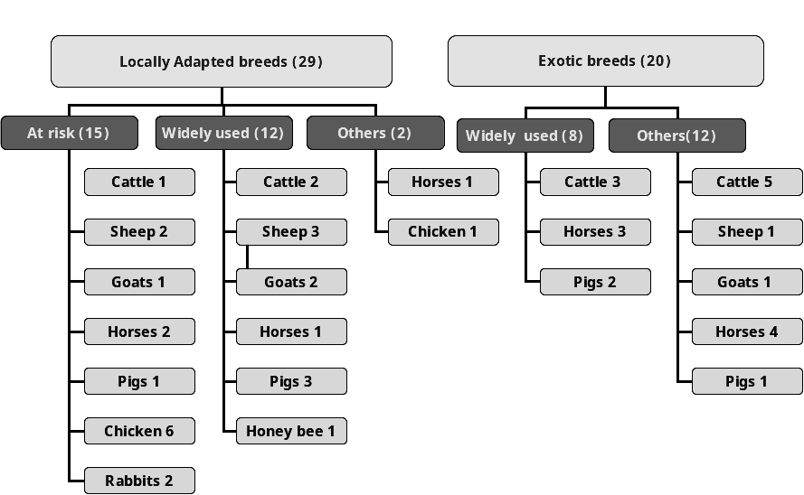

Some less frequent species and breeds can also be found in Slovenia. They are present only occasionally or number only a few animals. There are 124 breeds that are kept only by hobby breeders or fanciers (60 breeds of chickens, 3 turkeys, 11 ducks, 7 geese, and 43 breeds of rabbits). Mouflon (Ovis musimon) and wild boar (Sus scrofa) are the only still present wild ancestors of farm animals in Slovenia. The introduction of more profitable breeds in past decades has brought about a gradual disappearance of less productive Slovenian autochthonous breeds or their blending with newly introduced breeds. Livestock production now involves fewer and fewer autochthonous breeds, and for this reason some breeds have been lost completely (6 breeds have been lost in the last 50 years). Some other breeds still exist but only as the last remnants of them. Biodiversity in animal production has been strongly impacted by reduction and loss of agricultural lands (overgrowing, urbanization of land etc.). All this is affecting rural ecosystems and impacting in a negative sense on the diversity of agricultural genetic resources. Information concerning the status of individual breeds is more accurate for breeds that hold more importance in food production, given the higher level of breeding and selection activities of those breeds.
Systematic monitoring and analysis of the state of biodiversity is conducted, according to the Livestock Breeding Act, as a public service within the context of the gene bank in animal production. The method of monitoring biodiversity in animal production is directed by the MAFF. Biodiversity in animal production is a constituent of the Biodiversity Conservation Strategy of Slovenia (2). It was adopted by the Government of the Republic of Slovenia in 2001. The MAFF has also approved a program of "Conservation of biodiversity in animal production in Slovenia from 2001 to 2008" (3). The Livestock Breeding Act details 18 autochthonous breeds (including 5 breeds of dogs) that are being preserved in the autochthonous environment as an in situ gene bank. Slovenia has thus taken the first steps towards systematic conservation of AnGR biodiversity. A program of conservation in the form of frozen semen is performed in Slovenia in cattle.

Farm animal species in Slovenia vary in importance given the specific structure of the land (predominance of grasslands), and the substantial share of lands with unfavourable (limiting) conditions for cultivation. Horses and ruminants are the most important farm animals, especially cattle. Consumers of animal products, and the food industry, indirectly influence the importance and consequently the inventory of a particular species or breed. The importance of exotic breeds (cattle, pigs, and poultry) has been increasing in recent decades because of strong intensification in animal production. In small ruminants and horses, most emphasis has been placed on locally adapted breeds (autochthonous and traditional). The importance of locally adapted breeds is currently growing in cattle, and to some extent also in pigs and poultry. However, the number of new imports of animals and breeds to Slovenia is growing in all species.

Given current state in conservation and utilization of AnGR in Slovenia, future work should concentrate on some priorities. They are numerous, but the following seems to be the most important: (i) preventing overgrowing of agricultural land, (ii) strategy of sustainable food supply, (iii) environment- and animal-friendly rearing technologies, (iv) conservation of farm animals biodiversity, (v) utilisation of AnGR with more attention to be accorded to critical areas, (vi) implementation of national policy in animal production, and (vii) modernisation of national infrastructure in animal production

THE RESEARCHES OF SLOVENE AUTOCHTHONOUS AND OTHER FARM ANIMAL BREEDS

In the year 2003 the following research works were prepared:

- Chemical composition of copone meat
- Chronological development and the origin of Slovene Bovec sheep breed
- The English thoroughbred horse in Slovenia after the year 1960
- Chemical composition of milk of two grazing dairy goat breeds
- Aplication of molecular genetic methods in preservation of animal genetic resources in Slovenia
- The Bela Krajina sheep – conservation strategies

HOMEPAGE: PUBLIC SERVICE TASKS OF GENE BANK IN SLOVENE ANIMAL HUSBANDRY

On the WWW site: http://www.bfro.uni-lj.si/Kat_center/genska_banka/Default.htm
“Gene bank in farm animal husbandry” home page was created in the year 2003.

PUBLIC SERVICE TASKS OF GENE BANK IN ANIMAL HUSBANDRY

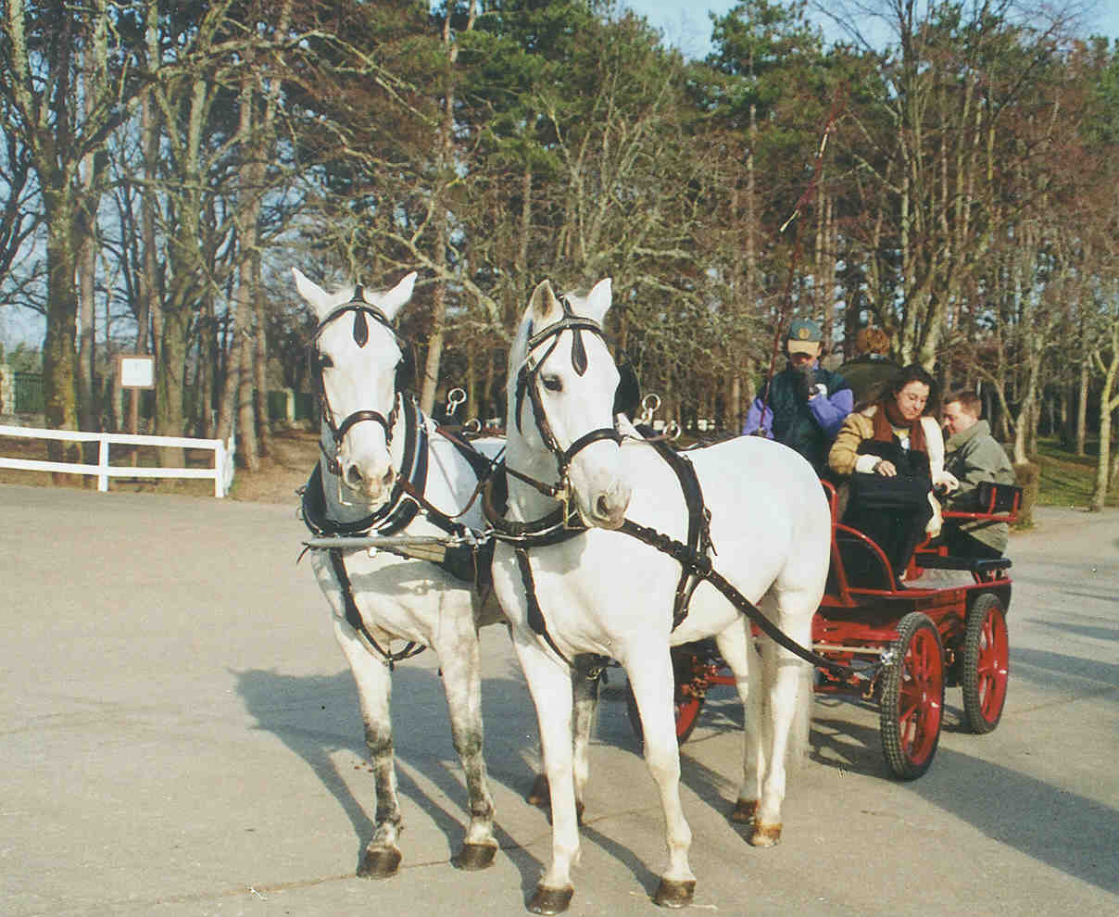 | THE STATE OF FARM ANIMAL GENETIC RESOURCES IN SLOVENIA  PROGRAM 2001 - 2008:  CONSERVATION OF BIODIVERSITY IN ANIMAL HUSBANDRY IN SLOVENIA
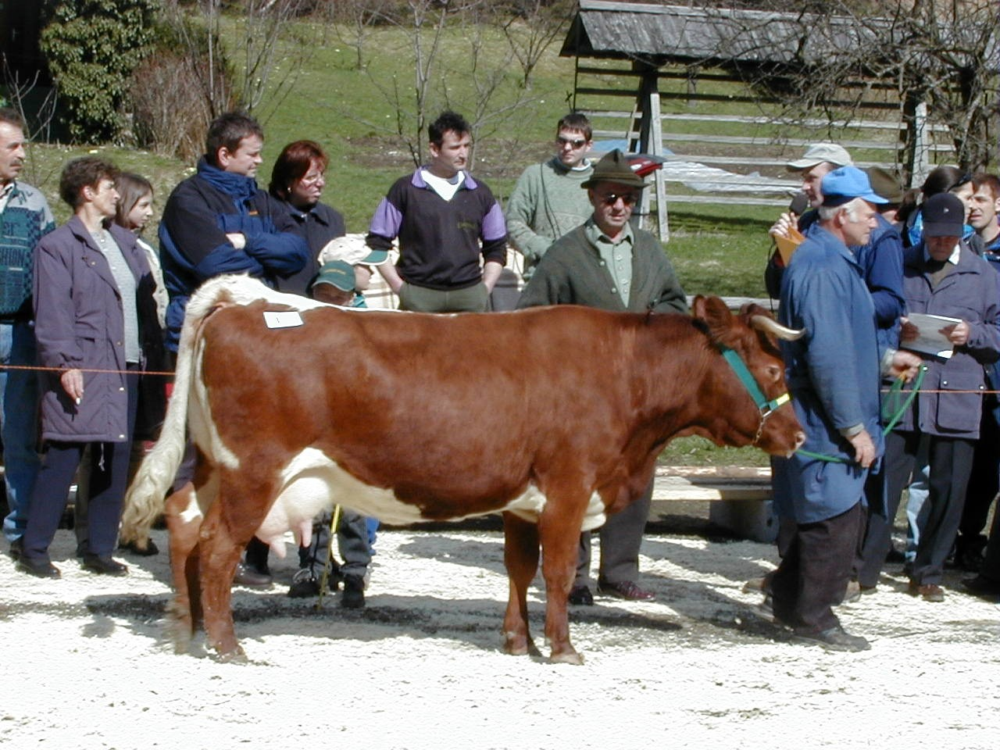 | - Autochthonous breeds  - Gene bank  - Conservation IN SITU  - Conservation EX SITU  - The list and description of Slovenian locally adopted breeds  - Legal regulation  - Education  - International co-operation  - Research  - Research Staff
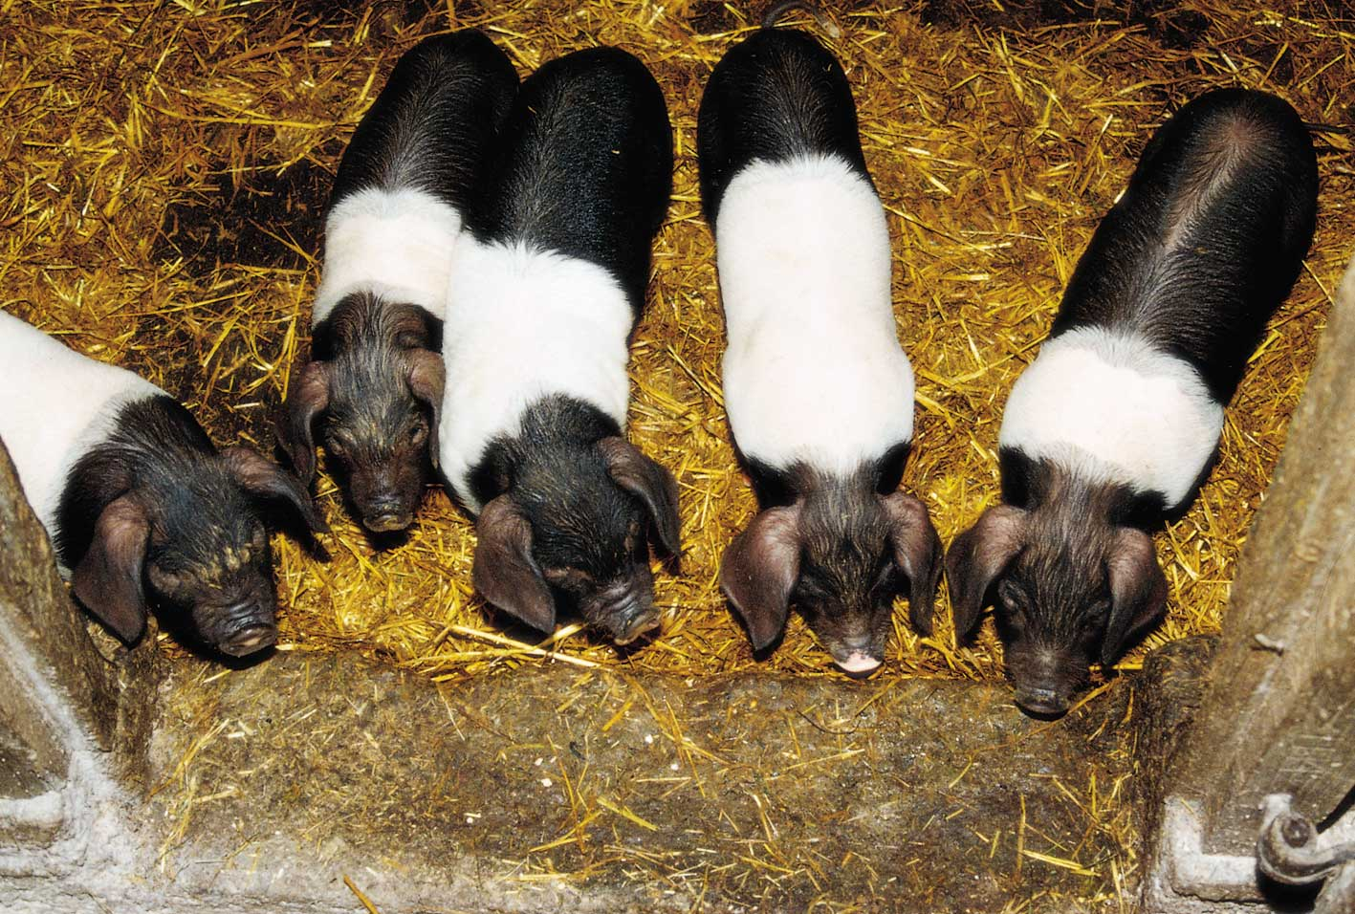 | 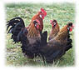 | 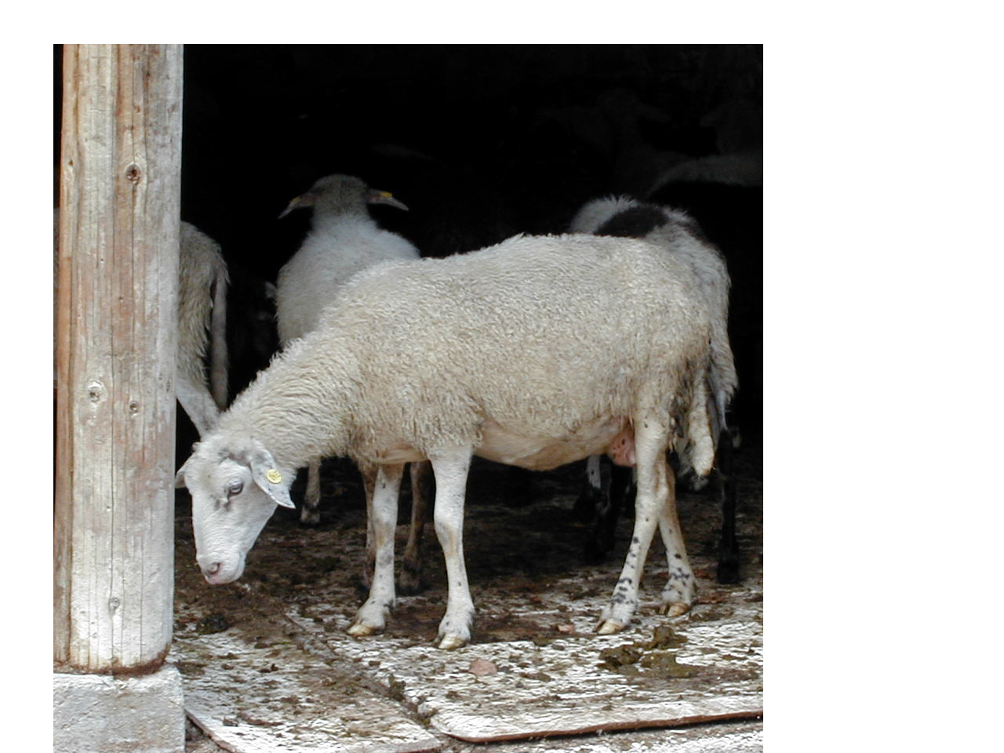
Questions or comments?   | Telefon: ++386 (0)1 72 17 995  Fax: + +386 (0)1 72 41 005  Modified Date:

EDUCATION ON THE CONSERVATION OF FARM ANIMAL BIODIVERSITY

Curriculum of the post graduate biological and biotechnical studies at the Biotechnical Faculty, University of Ljubljana, the M. Sc. study in the frame of Preservation of natural heritage includes the subject titled “Preservation of endangered farm animals”, and in the frame of Agriculture – Zootechnics the subject titled “Conservation of biodiversity in farm animals”.
In the year 2003 the following tasks were completed regarding the education for the requirements of biodiversity in animal production:
There was one post graduate student who enrolled the subject “Conservation of biodiversity in farm animals” and worked on the following topic for his seminar: How could the Carniolan bee be preserved?

His research included:
- The origin and development of Carniolan bee breed
- The present state
- Why didn’t Carniolan bee mix with other breeds, or has it?
- The significance of the preservation of Carniolan bee
- The programme of Carniolan bee conservation in Slovenia

In the frame of post graduate studies Preservation of natural heritage two M.Sc. Thesis were completed:
Promoting autochthonous domestic breeds in protected areas - the case of Karst Regional Park and Regional Park Snežnik

In the last decades older farm animal breeds have been pushed aside, therefore many disappeared, and those that have survived and have been preserved, are mostly all endangered. Their inventory will hardly stay stable, it will be difficult to preserve them. It means that these breeds will have to be directly economically activated. In Slovenia apart from the already secured areas, new regional and country landscape parks have been proposed, two of them being Karst Regional Park and Regional Park Snežnik. Considering the role and preservation of Slovene autochthonous farm animals both parks offer promising preservation possibilities, especially for those animal breeds that are autochthonous in these particular regions. The main goal of this research was to find the answer to the following questions: which autochthonous farm animals will be included in the preservation plan in these two parks, why here, (how (in view of production), what benefits and importance can be expected for the chosen breeds, what financial and other stimulations can breeders of autochthonous farm animal breeds expect, how and which special traits of autochthonous animals can be offered to the consumer, and what future regulations should be introduced in this matter by the government, local community and park management.

Biodiversity conservation in the Slovene agriculture in view of international legislation

The Republic of Slovenia has to allow and ensure efficient biodiversity preservation programme in agriculture, which will correspond with world conventions, and at the same time respect the European Union legislation. As yet, Slovenia has not made a formal and efficient system of biodiversity preservation in agriculture (BPA). The main objective of this study was to find the differences (deviations) between the European and the world legal norms in BPA. It is our wish to find the important factors influencing the BPA policy, the understanding of which has developed mainly in the last thirty years. The preservation technologies changed quite a lot during this period, both ex situ and in situ. Another aim of this research was also to judge certain events, which are at the moment in the field of utilisation of genetic resources, a topical subject and closely bound to the term intellectual property, where we can find a mixture of farmer’ rights and the rights of improvement experts. We will try to find and later propose the scientific and professional measures regarding agricultural plant production, farm animal production and similar, which have to be done if we want to prepare a professional plan and perform according to ecological measures. We shall also improve legal preservation of biodiversity in agriculture.

Attendance at the 6th International Course – CONSERVATION OF BIODIVERSITY IN DESERT ECOSYSTEMS

The »6th International Course – Conservation of Biodiversitry in Desert Ecosystems« was taking place from 04.05.2003 to 30.05 2003 at the Israeli »Ben Gurion University of the Negev the Jacob Blaustein Institute for Desert Research«.

Our colleague Metka Žan, B. Sc. Anim. Sc., applied for the educational course in Israel. All the expenses were covered by the Department for the International Cooperation and the Israeli Ministry of Foreign Affairs in the frame of MASHAV. The course included lectures, laboratory work, and fieldwork. There were 22 attendants from 14 countries. Lectures were held by highly professional experts (20), mostly foreigners. The main topics were as follows:

- Components of Biodiversity and Evolution (Adaptation and Speciation, Natural Selection, Coevolution, Production of biodiversity, Reproductive isolation, Types of speciation, Parapatric speciation, Sympatric speciation,…)
- Biogeography (The limits of species distribution, Relationships between climate and vegetation types, Biomes (Life Zones),…)
- Introduction to biodiversity measurement (Indices and Models, Species richness, Spatial Patterns of Biodiversity, Species-area curves, Species-area curves among large, Pieces of a single biota, Latitudinal gradient, Habitat variety,…)
- Desert biodiversity (Habitat variety, Threats and special concerns in desert ecosytems, Sampling methods, Identification of habitats and important geomorphological features, Monitoring protocols for desert organisms, Experimental designs to test effects of human disturbance,…)

All members had to prepare an individual project which was presented publicly at the end of the course. For the successfully prepared project titled »Diet quality and time budget in desert rodents« Metka Žan received a certificate given by the Ben Gurion University of the Negev the Jacob Blaustein Institute for Desert Research and Mashav Ministry of Foreign Affairs Center for International Cooperation.

Sustainable agriculture and rural development

During the one year full – time study Danijela Tomazic finished MSc (Master of Science) in Sustainable Agriculture and Rural Development. Study was completed at Imperial College of Science, Technology and Medicine in London, Department of Agricultural Sciences. School year started on 29 September 2002 and finished in September 2003. For the first term the student studied eight courses In the second term, the student specialised in Agrobiodiversity.
Agrobiodiversity option course gave the student the opportunity to develop:
- knowledge of the key issues of in situ and ex situ plant and animal genetic resource management;
- understanding of the on-farm, economic, environmental, social and political issues which may constrain the development of effective genetic resource policies;
- appreciation of the key management issues for long-term conservation of genetic resources;
- the ability to assess critically the genetic resource opportunities of a wide range of plant or animal species in agricultural systems;
- skills to prepare workable genetic management plans for a diverse range of situations and to implement and run genetic resource programmes.

FARM ANIMAL GENETIC RESOURCES AND LEGISLATION IN SLOVENIA

Farm animal genetic resources and legislation in Slovenia:
1920 - MEMORANDUM FOR PROTECTION OF NATURE (The Carniolan bee)
1991 - CONSTITUTION OF THE REPUBLIC OF SLOVENIA (Protection of Natural and Cultural Heritage)
1993 - ENVIRONMENTAL PROTECTION ACT ( permanently conservation of biological diversity
1996 - C O N V E N T I O N ON B I O L O G I C A L D I V E R S I T Y (Ratification)
1999 - NATURE CONSERVATION ACT (agricultural biological diversity is not included)
2000 - LAW ON AGRICULTURE (The basic regulations on biodiversity in agriculture)
2001 - SLOVENE AGRI-ENVIRONMENTAL PROGRAMME (The preservation of nature, biodiversity, soil fertility and traditional cultural landscape:
Measure II/5: Breeding of autochthonous and traditional breeds of farm animals
Measure II/7: Sustainable rearing of farm animals
2001 - BIODIVERSITY CONSERVATION STRATEGY OF SLOVENIA (The biodiversity in animal husbandry is the part of biodiversity conservation strategy of Slovenia)
2002 - LAW ON ANIMAL HUSBANDRY (6th Chapter: Conservation of genetic diversity and genetic reserve of domestic animals; Preservation of genetic diversity; Biodiversity in animal husbandry; Autochthonous breeds of domestic animals; Monitoring and analyzing biodiversity in animal husbandry; Safe keeping of autochthonous APIS MALLIFERA CARNICA BEES).

In the year 2003 Slovenia was trying to adapt its legislation in animal production to the European legal rights. Apart from the Animal Production Act, which was accepted in 2002, it published additional sub acts in the Government Gazette of the Republic of Slovenia:
Cattle production (7 regulations)
Pig production (11 regulations)
Small ruminant production (7 regulations)
Hoofed animal production (9 regulations)
Bee keeping (5 regulations)
Animal trade (3 regulations)

“Regulations on the conservation ob biodiversity in farm animal production” have been prepared , which takes over some of the tasks listed in the Animal Production Act. The Regulations have 50 articles, two supplements and consists of the following chapters:

I. General rules
II. Biodiversity in animal production
III. Genetic variability
IV. Acceptance of new breeds and lines of farm animals
V. Autochthonous farm animal breeds
VI. Traditional breeds
VII. Gene bank of agricultural animals genetic resources
VIII. Organization, legally responsible for the performance of public services in farm animal gene bank
IX. Final provisions

The Regulations correspond with the rules in:
- Animal Production Act,
- Biodiversity action plan for agriculture. 2001. – COM 2001 162 final VOLUME III. Brusseles, Commission of the European Communities,
Council Regulation (EC) No 870/2004 of 24 April 2004 establishing a Community programme on the conservation, characterisation, collection and utilisation of genetic resources in agriculture and repealing Regulation (EC) No 1467/94 (1).

INTERNATIONAL COOPERATION IN THE FIELD OF AnGR

Slovenia maintains the following forms of cooperation in the field of AnGR:

FAO – active work in the commission on genetic resources for food and agriculture.

Representatives of Slovenia are included in the cooperation with Intergovernmental Technical Working Group on Animal Genetic Resources for Food and Agriculture ITWG AnGR, where Slovenia is one of the five members of the closer working group representing Europe.

DAGENE – International non governmental organization of Danube countries involved with the conservation of biodiversity in animals, where members, members of the presidency, organizers, coorganizers are actively preparing different meetings and symposia.

SAVE – participation in the SAVE foundation (Safeguard for Agricultural Varieties in Europe). We are active in the Board of Directors, Management Committee in the preparation, direction and realization of projects (i. e. at the end of year 2003 the book titled Agricultural Genetic Resources in the Alps was published).

EAAP – participation in the presidency, forming working groups and commissions for cattle, horse and pig production, and the BABROC project. Slovenia and the University of Ljubljana, Zootechnical Department of the Biotechnical Faculty have been selected as the winning candidates for organizing the 55th EAAP Congress in Bled, 2004.

OTHER ACTIVITIES:
Cooperation with Bosnia and Hercegovina in the autochthonous farm animals protection, development and utilization of molecular methods for the preservation of gene resources of salmonide populations. With the Republic of Croatia the process of endema trout preservation is in process.

Cooperation in international projects:
INCO – Copernicus project with title: TRAIT GENE MAPPING IN A CROSS BETWEEN TWO DIVERGENT BREEDS - DUROC AND MANGALICA PIGS (INCO - Copernicus)

BIOTECHNICAL METHODS IN THE MAINTENANCE OF GENETIC DIVERSITY OF THE LIPIZZAN HORSE BREED INCO –Copernicus

Slovenia takes an active part in the preparation of strategy for the preservation of documents for the utilization of genetic resources, and actively participates in different biennial and international biodiversity projects.

SLOVENE AUTOCHTHONOUS FARM ANIMALS ON POSTAL STAMPS

The Post of Slovene (www.posta.si) issued four stamps with the motive of Slovene autochthonous breeds : the Cika cattle, the Jezersko-Solčava sheep, the Krško polje pig, and the Styrian hen on September 18th, 2003. This means the continuation of the series that the Post of Slovenia began in 1999 with the presentation of horses (Slovene cold-blooded horse, the Ljutomer trotter, Slovene warm-blooded horse and the Lipizzaner horse) on postal stamps. The series continued in 2001 with four stamps presenting bees (the working bee, the queen bee, the trot, and the bee swarm).

Presentation of postal stamps:

- The Cika cattle

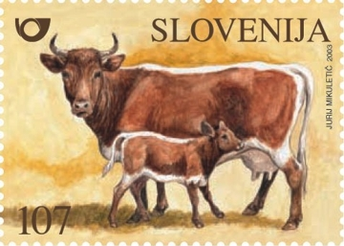

The Cika cattle has evolved from the light red single-coloured cattle, indigenous to the region of Bohinj, Slovenia (also known as the cattle of Bohinj). In the second half of the 19th century, the cows of indigenous breed weighed on average about 200 kg and produced relatively high milk yield (approximately 5 kg of milk per day). Still, they were inferior to the then Pinzgauer breed from the neighbouring Austrian provinces, which was known to be larger and more productive. To improve the qualities of the indigenous breed, the then authorities encouraged the import of Pinzgauer bulls. Crossbred cattle, which were similar in colour to the Pinzgauer breed, were named Cika. Depending on the geographical habitat, two varieties have been formed – Bohinj Cika Cattle and Tolmin Cika Cattle. The Bohinj variety is smaller, which is a result of the selection of smaller animals that are better adapted to breeding in mountainous regions and of the prevention of crossbreeding with the Pinzgauer cattle. In 1950 there were about 80,000 animals. In the years to follow the Cika cattle became almost extinct through breed substitution. Though the numbers of the Cika breed have increased in more recent years, it is still considered endangered livestock species by international standards.

- The Jezersko-Solcava sheep

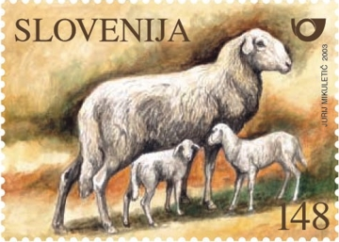

The Jezersko-Solcava sheep is Slovenian indigenous sheep breed, reared for its excellent quality meat. The breed is medium sized with a characteristic convex head profile and high quality wool. The animals have large ears and a long wool-covered tail. They are predominantly white, but dark brown or black variations also occur. Some animals are distinguished by a black circular patch around the eyes and on their ear tips. The lower parts of their legs may also be colored. Due to these "eyeglass" marks, they are called bespectacled sheep (the "Brillenschaf" in the neighboring Austria, where they are also reared). The animals have long muscular legs, and a strong and long back. This allows them to walk on steep mountainous grazing land. The breed has a well deserved reputation as a prolific sheep (it is fertile all year round), and twins or triplets are not unusual. The Jezersko-Solcava breed of sheep is an integral part of Slovene natural and cultural heritage and is included in a special programme for the conservation of indigenous livestock breeds.
- The Krsko Polje pig

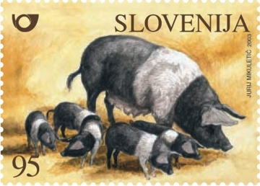

The "Krsko Polje" or "blackbelted" pig is Slovenia's sole indigenous pig breed. The breed is most noted for its hardiness, ability to adapt to poor rearing conditions and feed supply, and for excellent meat quality. The first extensive description of the Krško polje pig was published towards the end of the 19th century by Rohrman (1899). After World War II articles were published in the fifties and sixties. After 1972 the interest in the research of this breed has diminished. In the period between 1990 and 1992 research work was carried out to determine the number of Krsko Polje pigs in the Gorjanci, Brežice and Krško polje districts. The breed was listed as Slovenia's endangered domestic livestock breed and efforts have been made to conserve the breed by intensified breeding. The Krško polje pig breed is characterized by an average prolificacy, good feed efficiency and rapid growth. It produces meat of very high quality, which is particularly well suited to air-dried ham production.

- The Styrian Hen

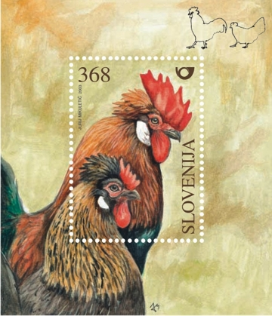
The Styrian hen is Slovenia's only indigenous breed of hen. It originates from the region between the rivers Mura and Sava in the Slovene Styria and the southern part of Austrian Styria. The Styrian hen was mentioned as early as the 14th century. In the past centuries, it was highly thought of, especially for the tender and tasty meat of the Styrian capon. Still, the breed has been on the verge of extinction several times. In the past, there were four different color varieties: light brown, partridge-colored, white and barred. To date, only the partridge-colored variety has been preserved. It is very rare and therefore identified as a vulnerable or endangered population. The Styrian hen is characterized by a tuft of feathers behind its comb. Today, the productivity of the Styrian hen is too low to be of economic value. Still, it is worth of preservation for its unique breed traits and genetic identity, which are particularly suitable to Slovenia. Its excellent foraging ability and other distinctive characteristics make it ideally suited to farmyard production systems.

SLOVENE AUTOCHTHONOUS AND TRADITIONAL FARM ANIMAL BREEDS - INVENTORY FOR THE YEAR 2003

Slovene autochthonous farm animal breeds inventory for the year 2003:

AUTOCHTHONOUS BREEDS | YEAR | Estimation of total number of purebred animals | No. of female | No. of female in gene bank | Data in international data bases
 |  |  |  |  | DAD-IS | EAAP-AGDB | OKLAHOMA
Cika cattle | 2003 | 900 | 550 | 300 | YES | YES | -
Lipizzan horse | 2003 | 650 | 350 | 70 | YES | - | -
Posavje horse | 2003 | 700 | 546 | 103 | YES | YES | -
Slovenian Cold-  Blooded horse | 2003 | 1120 | 560 | 229 | YES | - | -
Krsko Polje pig | 2003 | 350 | 100 | 36 | YES | YES | YES
Jezersko-Solcavska sheep | 2003 | 21.000 | 9.800 | 990 | YES | YES | YES
Bovec sheep | 2003 | 4.000 | 2.280 | 818 | YES | YES | YES
Istrian Pramenka | 2003 | 1.700 | 930 | 428 | YES | YES | YES
Bela Krajina Pramenka | 2003 | 760 | 500 | 386 | YES | YES | -
Dreznica goat | 2003 | 550 | 380 | 181 | - | YES | -
Styrian hen | 2003 | 1.200 | 1.100 | 304 | YES | - | YES
Carniolan Honey bee | 2003 | - | 15700* | - | - | - | -
*:No. of hives
Slovene traditional farm animal breeds inventory for the year 2003:

TRADITIONAL BREEDS | YEAR | Estimation of total number of purebred animals | No. of female | No. of female in gene bank | Data in international data bases
 |  |  |  |  | DAD-IS
Simmental cattle | 2003 | 240000 | 110000 | - | YES | YES | -
Slovenian brown cattle | 2003 | 75000 | 34500 | - | YES | YES | -
Ljutomer trotter | 2003 | 1.100 | 260 | - | YES | YES | -
Swedish Landrace | 2003 | 26691 | 6268 | - | YES | YES | -
German Landrace | 2003 | 4118 | 727 | - | YES | YES | -
Large white | 2003 | 11459 | 1637 | - | YES | YES | -
Improved Jezersko – solcava sheep | 2003 | 92000 | 6672 | - | YES | YES | -
Slovenian Saanen goat | 2003 | 4.700 | 2.900 | - | YES | YES | -
Slovenian Alpine goat | 2003 | 15.800 | 9.800 | - | YES | YES | -
Slovenian Barred hen | 2003 | 915 | 700 | - | YES | - | -
Slovenian Silver hen | 2003 | 420 | 350 | - | YES | - | -
Rhode Island Red | 2003 | 2400 | 2120 | - | YES | - | -
White Plymouth Rock (line: B) | 2003 | 365 | 330 | - | YES | - | -
White Plymouth Rock (line: P) | 2003 | 365 | 330 | - | YES | - | -
Slovenian Synthetic line (WM) | 2003 | 355 | 325 | - | YES | - | -

SUBSIDIES FOR BREEDERS FOR THE REARING OF AUTOCHTHONOUS FARM ANIMALS

Direct allowance:
Species | Subsidies per animal (in EUR) | Yearly allowance (EUR)
Horses | 84 | 33.613,00
Cattle | 102 | 24.580,00
Pigs | Boars:147  Sows and gilts: 105 | 6.933,00
Sheep | Dairy breeds:29  Meat breeds: 21 | 65.126,00
Goats | 21 | 6.302,00
Chicken | 4,2 | 2.101,00
TOTAL |  | 138.655,00

