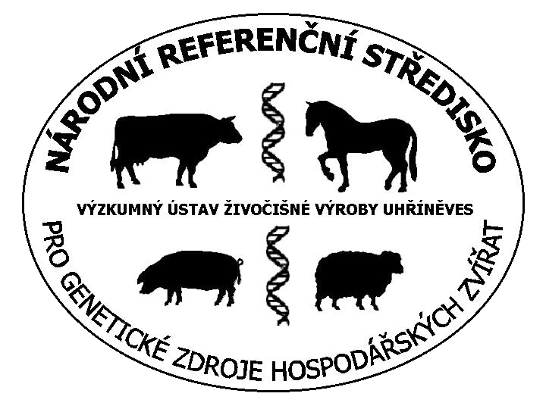
Farm Animal Genetic Resources NFP - Czech Republic
Annual activity report 2004

Legislative and political progress
Consolidation of the AnGR legal status has been the most important issue of the NFP. Together with other focal points we have prepared and through the Ministry of Agriculture proclaimed an integrated National program on conservation of genetic resources, involving both plants, micro organisms and farm animals. It became into force on 1.1.2004. In addition, an amendment of the Farm Animal Breeding Law is now elaborated where a new concept of preservation and development of AnGR takes a place. Both plant and animal GR issue, especially budgetary support of gene banks function and further research on genetic resources has been included also into the National Biodiversity Strategy which becomes an official state document during 2004.

Databases
For the needs of both National Program and National CBD Clearinghouse Mechanism an intermediate progress in database, linking between NFP and breeders associations has been achieved, enabling more precise monitoring of breeds.

Public awareness
The extensive promotion plan holds on. Except information and presentation leaflets distributed during all agri and animal shows, equestrian events etc., we have distributed an educational video/DVD film to junior, high and technical schools. In successive manner we are issuing monothematic books concerning each protected breed (so far two of them are edited, on the Prestice pig and Gold Brindled hen).

Cryopreservation
Based on thee ERFP Paris-SIMA Workshop recommendations we have redesigned the sampling procedure. However, much more discussions and explanations about ownership and disposal rights on cryopreserved material are needed, as some farmers do not understand well the role of genebanking.
We have made substantial effort in strengthening capacities of using molecular genetic methods for description and population analyses of breeds and developing new research activities in this line. During the last period we also succeeded to collect a plenitude of DNA smples for description and

Activities planned for the next year
The main task resulting from the SoW process is to manage a reasonable utilization of local breeds not relying on subsidies by the means of wider personal contacts and discussions with farmers. The generally unsensed situation and future expectations in the whole agricultural sector following the EU accession does not act positively on this effort. In some breeds, despite subsidies, we are not able to halt a descending trend (see the chart below).

Co-operation sought
For the research project on local, we seek for a co-operation in collecting and exchange of DNA samples for continuation of description and distancing studies, especially on the red cattle, goats and sheep. We are able to follow FAO-recommended procedures and standards and possess capacities to elaborate required amount of analyses

Vera Matlova (NC)
Prague, June 23rd 2004

Species | Number of farmed breeds : |  |  | Names of protected breeds  (names in bold critically endangered,  < 100 breeding dams) | Trends in  protected breeds  (2000-2003) | Number of supported farms / animals  in 2003
Species | Indigenous and  locally adapted | Exotic and recently introduced | Protected genetic resources |  | Trends in  protected breeds  (2000-2003) | Number of supported farms / animals  in 2003
dairy cattle | 3 | 15 | 2 | Czech Red Cattle  Czech Red Pied Cattle | +  S | 4 / 117  0
sheep | 8 | 18 | 2 | Shumavska  Valachian | ++  ++ | 29 / 2734  14 / 148
goats | 2 | 4 | 2 | White Shorthaired  Brown Shorthaired | S  ++ | 229 / 1627  97 / 687
pig | 4 | 5 | 1 | Prestice Black Pied | S | 9 / 371
horse | 6 | 12 | 4 | Old Kladruby Horse  Hutsul  Silesian Noric  Czech-Moravian Belgic | +  +  + | 32 / 77  24 / 48  13/ 15  59 / 62
poultry | 27 | 23 | 2 | Czech Gold Brindled Hen  Czech Goose | -  - | 7 / 307  24 / 152
rabbit | 20 | 2 | 7 | Moravian Blue, Bohemian Albinotic, Bohemian Lofer, Bohemian Spotted, Moravian Brown-eyed, Bohemian Red, Bohemian Black Kemped | - / -- | 137 / 946
nutria | 12 |  | 3 | Standard  Silver  Prestice Tricolor | S  S  + | 7 / 91  6 / 56  1 / 16
freshwater fish | 32 | 23 | 7 | local lines of:  carp, tench, salmon trout, rainbow trout. catfish, whitefish, sturgeon | S | 10 / 480
honey bee | 1 |  | 1 | Carniolan | S | 7 / n.a.

Tab 1. Numbers and trends in Czech Farm animal genetic resources

