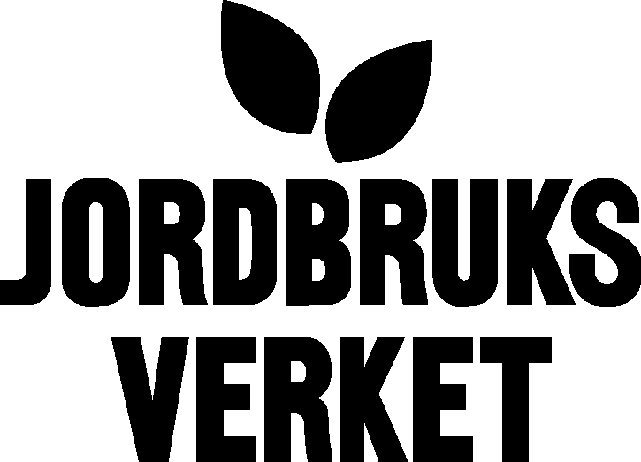  Swedish Board of Agriculture |  | 2006-07-19
Department for animal production and health
Eva-Marie Stålhammar

Annual report 2005/06 on activities on AnGR in Sweden

Accomplished tasks
- Farm Animal Control Act (in Swedish lag (2006:807) om kontroll av husdjur m.m) issued 2006, June.
An additional purpose has been put in to pay attention to long-term management of the biodiversity.
This change will give the Swedish Board of Agriculture (SBA) increased possibilities to guide and control breeding organisations and breed associations in managing AnGR.
- The European Union (EU) will launch a new Rural Development Programme from 2007.
A small part of the programme considers environmental compensations for conservation of endangered breeds. SBA has suggested some new activities to reach the goal for endangered breeds.
- A plan to save animal genetic resources during catastrophic circumstances.
Different kinds of catastrohpic events can cause large negative consequenses on small populations, rare breeds and important breeding stocks as well as on ex situ animal genetic resources. In order to be better prepared to handle these situations with a focus on animal genetic resources, Sweden has developed a general contingency plan. The work will continue with breed specific contingency plans.

Future activities
- The Swedish environmental objective - A varied agricultural landscape
SBA has been commissioned by the government to improve the goal for number of animals. The goal should be more differentiated, in this case we suggest no breed will have the status critical, like the FAO criteria.
- In the Swedish Rural Development programme sent to EU the SBA has suggested to give financial support to the breed associations for endangered breeds to support registration work, which the breed associations perform.
- New goals for animal genetic resources
The Swedish goal that all Swedish domestic animals year 2010 should be as numerous that a long-term preservation is secured, shall be followed by a new goal from 2010 to 2020. During this work, a thorough analysis of all breeds is carried out.

