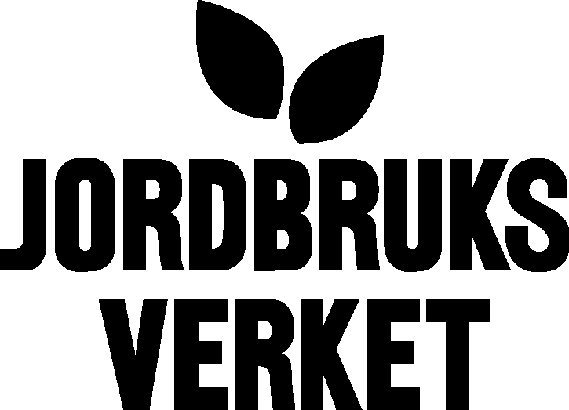  Swedish Board of Agriculture |  | 2005-04-29
Division of strategic issues
Eva-Marie Stålhammar
E-mail: eva-marie.stalhammar@sjv.se

Annual report 2004/2005 on activities of AnGR in Sweden

An official letter concerning AnGR from the government to the parliament has created a lot of tasks in a positive way for the Swedish Board of Agriculture (SBA). The letter was a reaction to an earlier report from SBA..
The SBA has been commissioned by the government to
- Initiate different groups - one to strengthen information tasks among the associatons for endangered breeds, a committee for AnGR to support SBA in this field and also a group, which takes a broader grip on both plant, forest and animal genetic resources.
- Emergency plans for endangered breeds/spieces in case of catastrophy.
- Systematically collection and storage of genetic material

An evalution of goals and means is to be done for the established 15 environmental quality objectives to guide Sweden towards a sustainable society. A varied agricultural landscape is the objective, which SBA is responsible for and it includes AnGR.

all of which will be accomplished during 2005 and 2006.
Initiating the committee for AnGR, which will support SBA in various issues e.g. the tasks mentioned above. The committee will agree on a plan for action for our future work with the AnGR in Sweden.

According to the report from the Swedish Board of Agriculture (2004:20) on identification and registration of horses there are 271 000 registered horses in Sweden. The report was forwarded to the government.

In June the 56th meeting of the European Association of Animal Production (EAAP) will be arranged in Sweden with several workshops and seminars on genetic resources.
The work with the new regulation on rural development, which at present is elaborated on in EU also has implications for our work in Sweden to develop a new programme for rural development, which will start in 2007.

SBA is working with the Nordic Gene Bank for farm animals in seminars and reports.

