European Regional Focal Point
For Animal Genetic Resources.
16, rue Claude Bernard  75231 PARIS cedex | Dominique PLANCHENAULT
Tel : 01.44.08.72.61  Fax : 01.44.08.72.63 | dominique.planchenault@inapg.inra.fr
Second announcement. | Paris, 1/07/2004

Dear Colleagues,

You are invited to participate in the Tenth Workshop being prepared for National Coordinators, and their support, for the countries of Europe. The Workshop will be conducted in Bled. The workshop will start on Saturday 4 September 2004 from 8:30 a.m. to 6:00 p.m. You will find enclosed the final agenda.
During the first part of our workshop, we will have an overview of the actions developed in 2003 - 2004 by the ERFP with particular focus on the projects. At the end of this morning, a specific time (half an hour) is preserved for a general discussion on the databases in Europe (your needs, your situation, etc.). After a quick lunch, the new projects, started in 2004, could be presented by the authors and three presentations will give you a good overview of the actions developed in the field of AnGR since Rome workshop. You will be able to present your own actions (meeting, project, actions,..) just before the coffee break. After that, we will have to decide the new actions and/or evolution for ERFP in 2004 – 2005. Following the decision of our last workshop, we will have to elect a new Steering Committee member and the ERFP secretariat. Please do not hesitate to contact me with any thoughts, feedback or comments you might have on these future perspectives for ERFP.
The first documents could be distributed at the beginning of the workshop. In this context, can you send me very soon your annual report? This country annual report should be maximum 2 pages long. We recommend the same structure for all:
Activities undertaken during the past year in the framework of AnGR.
Situation regarding your SoW Country Report.
Primary activities planned for the coming year.
The ERFP is able to provide financial support to assist your participation. We cannot help every body. We have a small budget to cover the travel cost of invited European countries. If we need this support, may I have your demand before the end of July? We will do the maximum to help you. But, we will be able to refund only the people who received an authorization. However, I ask you to do the maximum to come.
It's now a tradition; the chairman of our workshop is the ERFP-SC president. I ask for a volunteer to be the rapporteur. I thank you in advance for your collaboration. Be free to say yes!
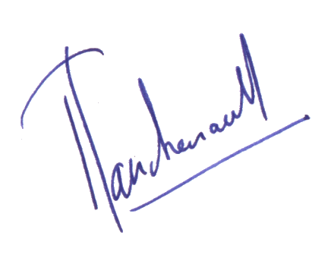
For your necessary arrangements, you will find information in the website of the EAAP meeting. (http://www.bfro.uni-lj.si/eaap2004/default.asp). For organisational reasons, I must send very soon a list of participants coming to this 10th workshop. Please, send me your confirmation (or the person standing in for you) as soon as possible?
Hoping to see you in Bled.

Dominique PLANCHENAULT
Programme of the 10th Workshop for European National
Co-ordinators for the Management of Farm Animal Genetic Resources.
Bled September 4, 2004.

Saturday 4th | Agenda
8:30 – 9:00 | Opening of the 10th meeting | J. BOYAZOGLU and  R. CARDELLINO
9:00 – 9:30 | Annual report of the European RFP + Discussions | D. PLANCHENAULT
9:30 – 10:00 | ERFP project - Guidelines cryopreservation. | S. HIEMSTRA
10:00 – 10:30 | Coffee Break.
10:30 – 11:00 | ERFP project – Databases implementation. | A. GEORGOUDIS
11:00 – 11:30 | ERFP Website | F. BEGEMANN
11:30 – 12:00 | Overview on EFABIS. | G. GANDINI
12:00 – 12:30 | General discussion on EFABIS and ERFP website.
12:30 – 12:40 | Technical announcements. | F. HABE
12:40 – 14:00 | Lunch break
14:00 – 14:30 | Others ERFP projects in course. | Open to new projects
14:30 – 15:00 | Progress on the First Report SoW-AnGR, Report on the Strategic Priorities and FAO intergovernmental meetings. | R. CARDELLINO
15:00 – 15:20 | Actions in collaboration with East European Countries | A. SVITOJUS
15:20 – 15:35 | The new European Genetic Resources regulation 870/04 | M. ROPER
15:35 – 15:50 | Heritage Sheep Breeds – a project proposal | S. JONES
15:50 – 16:00 | NC ad hoc announcements. | Free for NCs
16:00 – 16:30 | Coffee Break.
16:30 – 16:40 | Future actions of ERFP - Actions at regional and national level. | M. ROPER
16:40 – 17:00 | Discussion on workplan 2004 -2005. | All NCs
17:00 – 17:20 | Recommendations for ERFP activities in 2003 - 2004. Mandate and Approval of Budget. | M. ROPER
17:20 – 17:40 | The ERFP – Election of a new member of Steering Committee – Election of the Secretariat
17:40 – 18:00 | Conclusion.
18:00 – 18:10 | Technical announcements. | F. HABE

